***God Creation and the Universe’s*** main objective is to dispel evolution and show from the Bible, prophetic prophecy, and Documented peer reviewed scientific facts, the evidence of creation by God. The presentation covers Gods creation from the perspective of outside the universe and everything in between down to your DNA.

The science discussion is on all aspects of Heaven, its location in our Galaxy, it’s dimension in size and its capacity to hold the inhabitants comfortably. Know where to look in the sky to see Heaven’s location visible to the naked eye. Use your cell phone as a star finder. See a vivid view of the location close up and the Hubble telescope’s real time magnification into the nebula, and the simulation of heaven behind the nebula like dark shroud around the Holy City. The view point of the structures of creation visible and invisible to the human eye, and the wonders of Gods highly complex signature is in all of His creation reflecting the design of a creator with intelligence unparalleled by anything in existence. All this backed up by the Bible itself culminating with God’s return and where in the time of history we are in Gods timeline. This presentation is to not only prove God as the creator but develop a deep yearning in all the listeners to love God with all their mind, body, and soul ending with their Total Praise to God 24/7.

[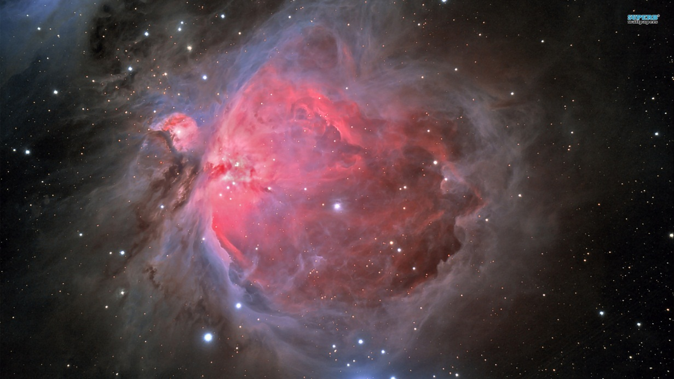](http://www.superbwallpapers.com/space/orion-nebula-5782/)

### Tag line goes here.

***Presented by***

***Dr. William R. Downes***

***Telephone: [239-443-7602]***

Williamdownes.wix.com/spaceadventures

# ***God Creation and the Universe***HOLDING%20OUR%20UNIVERS%20TOGETHERiverse

God Creation and the Universe

Scientific research Proven

Dr. William R. Downes

509 sw 13th st.

Cape Coral, Fl. 33991

Address Correction Required

|  |  |
| --- | --- |
|  |  |
|  | |
|  |  |
|  | |
|  |  |
|  | |
|  |  |
|  | |
|  |  |
|  | |
|  |  |
|  | |
|  |  |
|  | |

Application accepted for Astronaut candidacy selection in 2017

#### God Creation & the Universe

Dr. William R. Downes

509 SW 13th St.

Cape Coral Fl. 33991

Phone: (239-443-7602)

Fax: (239) 574-4637

E-mail: [William.Downes@sbcglobal.net](mailto:William.Downes@sbcglobal.net)

Web: Williamdownes.wix.com/spaceadventures

THE UNIVERSE AT LARGE

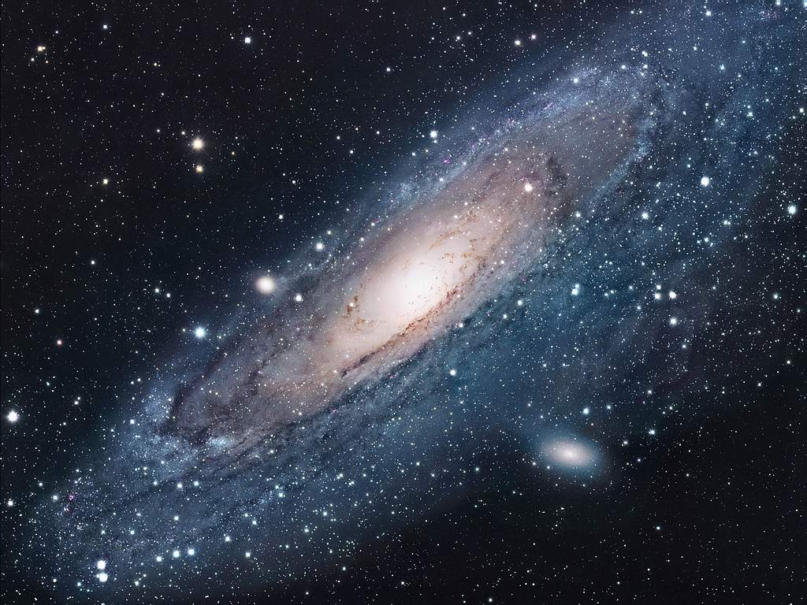

## Event Options:

1. Week of Creation: W, F, Sat., Aftn
2. Weekend: F, Sat.
3. Saturday: Divine hr.,

Aftn. session

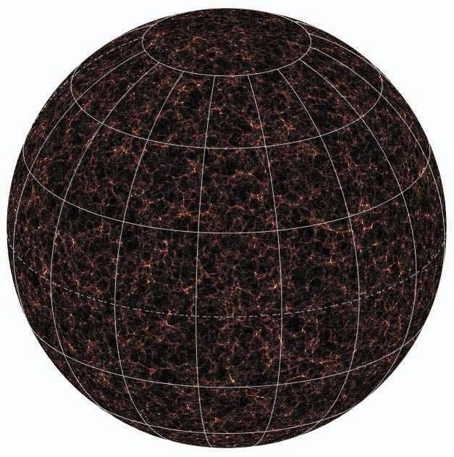

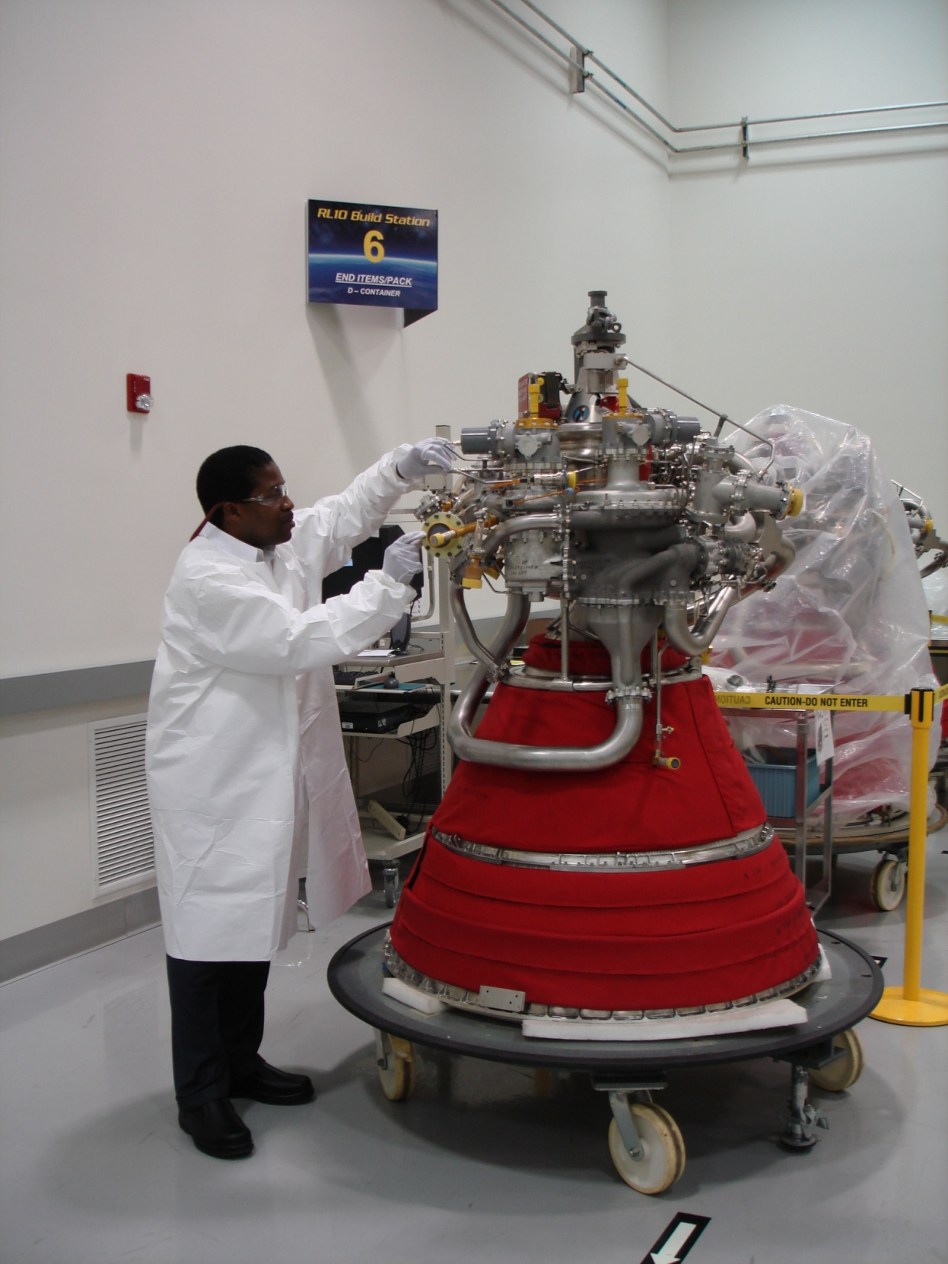

|  |
| --- |
| *You're invited to* |

|  |
| --- |
| **A Universe Presentation**  **Presented by**  **Dr. William Roger Downes** |

|  |
| --- |
| Please join us for a special event.  **Learn about the mysteries of Orion**    **Explore the wonders of the Universe**  **Free** Admission to All.  Bring family, friends and colleagues.  We look forward to sharing this special weekend with you. |

|  |
| --- |
| *When* |

|  |
| --- |
| ***Your Date 1, 20XX***  *11am to 12:45pm*  *2 to 4:30pm* |

|  |
| --- |
| *Where* |

|  |
| --- |
| **“Your Location”**  **MAIN AUDITORIUM** |

## 

### **Call to Book an event at your location.**